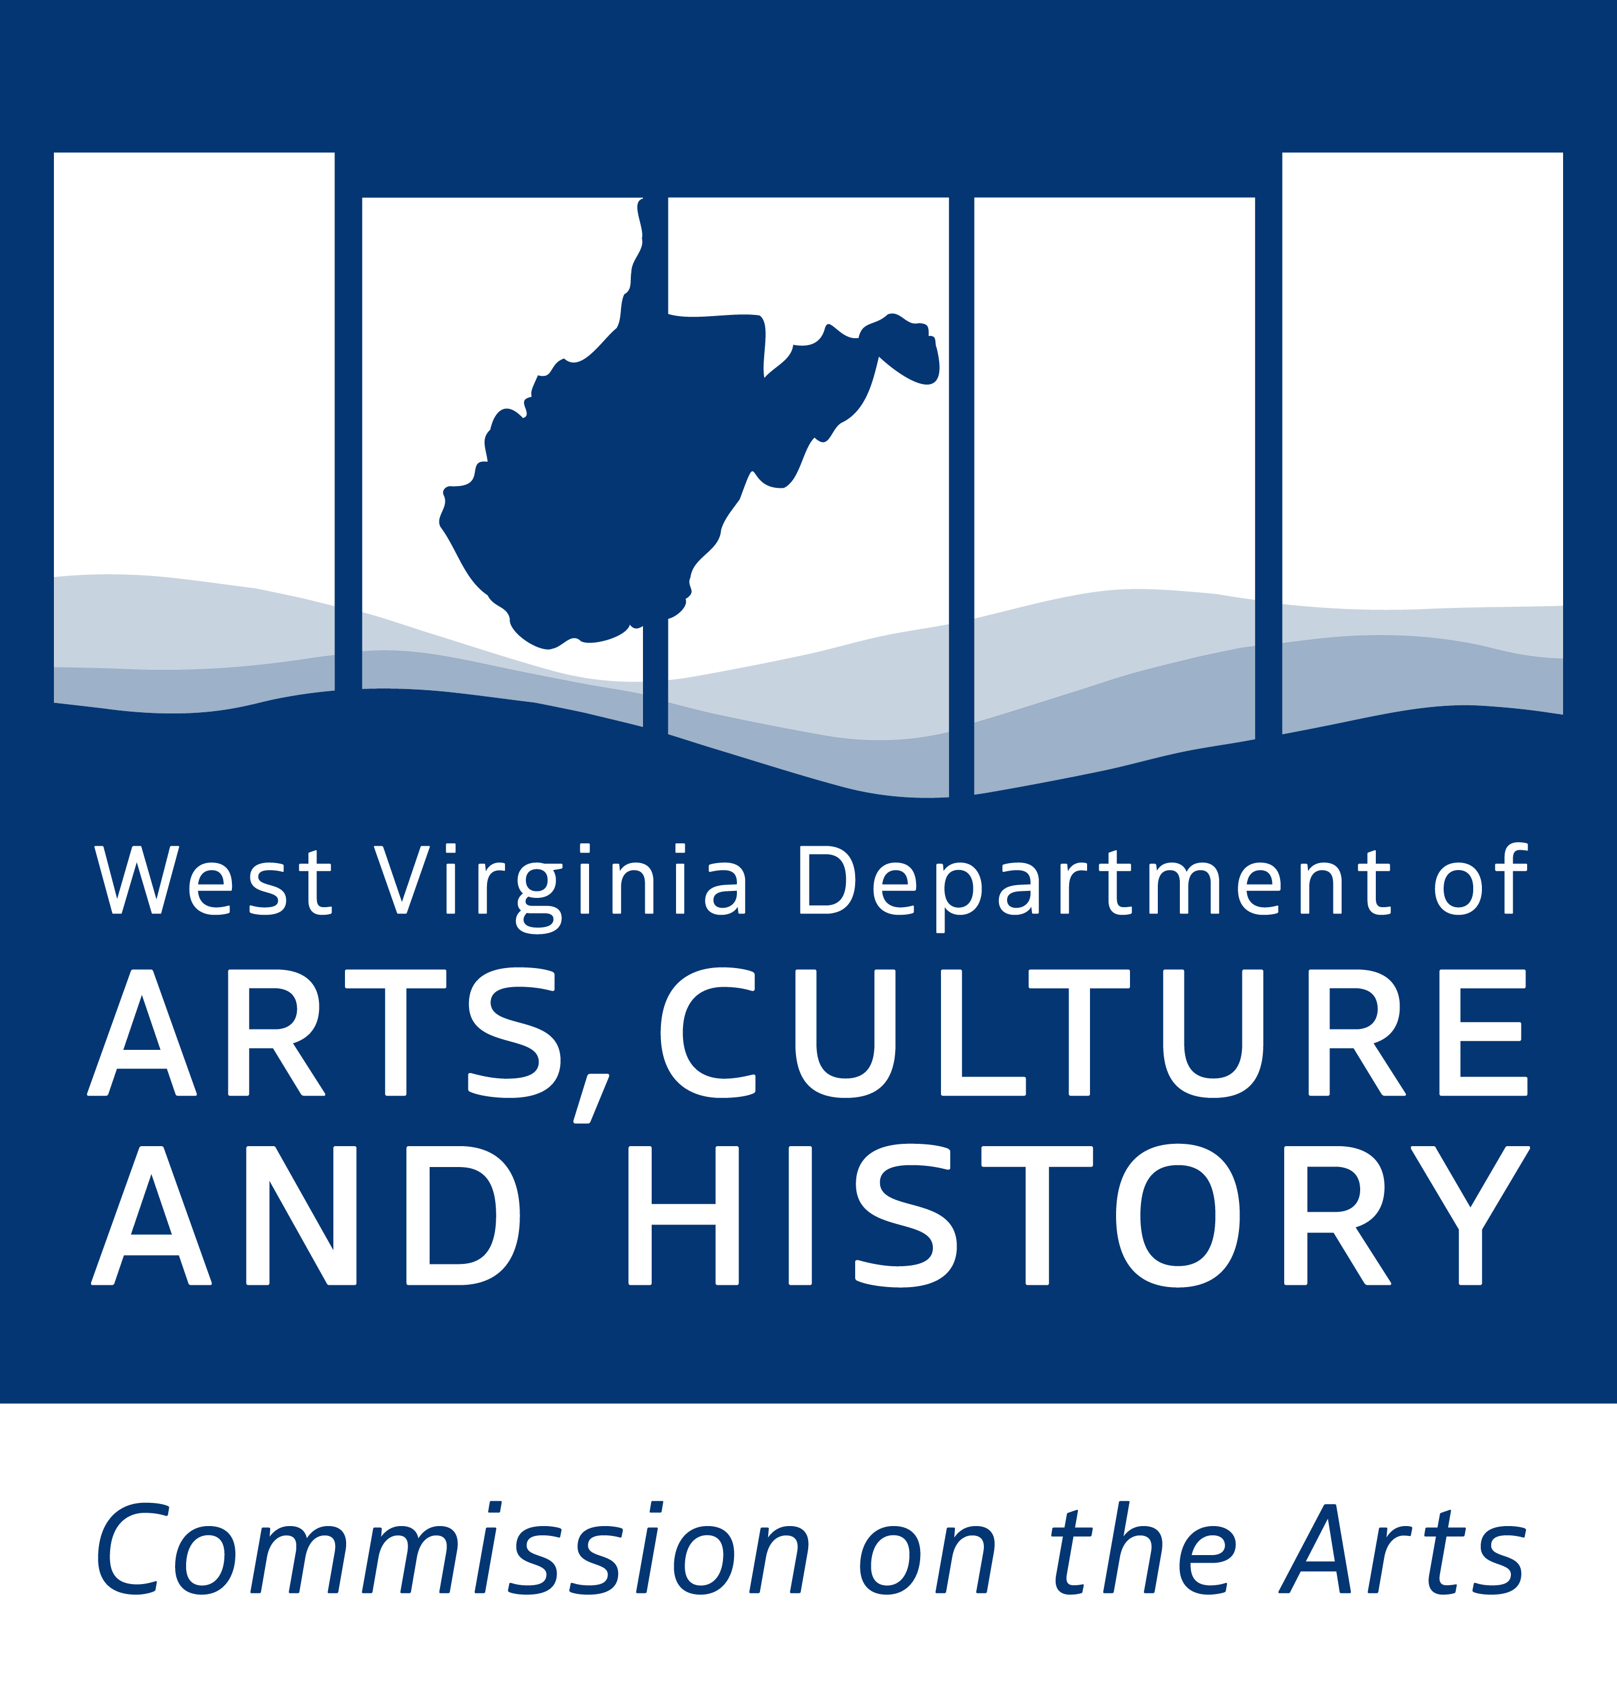
Final Report
American Rescue Plan:
Operating Support for Arts
Organizations

CONTENTS
Instructions and Final Report Form

PROGRAM CONTACT
Cedrick Farmer, Community Arts Coordinator
Cedrick.L.Farmer@wv.gov

This is a program of the West Virginia Department of Arts, Culture and History (WVDACH) & WV Commission on the Arts (WVCA)
The Culture Center / 1900 Kanawha Boulevard, East / Charleston, WV 25305-0300
P: 304-558-0240 / TDD: 304-558-3562
www.wvculture.org


All publications and application forms are available in alternative formats upon request. Contact ADA Coordinator at Jenna.R.Green@wv.gov
Or 304-558-0240 (phone) or 304-558-3562 (TDD)
All publications and application forms are available in alternative formats upon request. Contact Jennifer Strechay, ADA Coordinator, at
304-558-0240 ext. 152 (phone) or 304-558-3562 (TDD)

American Rescue Plan Operating Support for Arts Organizations
Final Report Instructions
Part I: Final Report Cover Sheet
- Enter awardee organization’s legal name and address.
- For Contact Person, enter the person to be contacted with questions.
- Final Report Budget Summary:
  - Enter Grant Amount Awarded (line A on the final report budget summary).
  - Grant Amount Spent: actual amount of awarded grant funds spent to complete the approved project (line B on the final report budget summary).
- Read the certification information carefully, sign and date in blue ink. Circle the accounting method used by your organization (Accrual/Cash).
- Final Report Cover Sheet must be notarized in the space provided by all grantees except governmental entities. Public PK-12 schools do not need notarization.

Part II: Narrative
- Respond to each narrative question to describe the completed project.

Part III: Documentation of Expenses
- Provide documentation of expenses as attachments to this final report.

Final Report Checklist:
Part I – Final Report Cover Sheet
Part II – Final Report Narrative
Part III – Attachments (documentation of expenses)

PART I: Cover Sheet
Do not write in this space
Date received: ______________________
Application #: ______________________
PRN: _____________________________
Applicant Legal Name (Organization):
Mailing Address: City:
County: State: Zip:
Contact Person:
Phone:
E-mail: Website:
FEIN Number:
Final Report Budget Summary
A) Total Grant Amount Awarded | $
- Total Grant Amount Spent | $
Certification:
I certify that I have reviewed the grant receipts and expenditures submitted within this final report and, to the best of my knowledge and belief, this report represents all financial activities related to the receipt, use, and expenditure of funds granted by the WV Commission on the Arts/WV Department of Arts, Culture and History, and that the expenditures reported were for the purposes intended and in compliance with applicable laws, regulations and the terms and conditions of the grant documents. The report of grant receipts and expenditures is presented on the ACCRUAL / CASH (circle one – required by State Code) basis of accounting and is supported by our financial records and related documentation.
Name: Title:
Signature: Date:

Notary required for all applicants EXCEPT governmental entities.

STATE OF WEST VIRGINIA
COUNTY OF _________________________________________________
I, ___________________________________, a notary public in and for the said state, do hereby certify that __________________________________, whose name is signed to the writing above, has this day acknowledged the same before me.
Given under my hand this _____ day of _______________, 20___
My commission expires__________________________________
______________________________________________________
Notary Public
PART II: Final Report Narrative Applicant Name (Organization):
How did your organization spend the awarded funds? Provide documentation of expenses as attachments to this final report.

How many staff and contract positions were supported by this funding? How many artists were employed because of this funding?

What impact did this funding have on your organization?

How did this funding support your programming and outreach to underserved populations?

What challenges are your organization facing post-pandemic?

